بسم الله الرحمن الرحيم
Republic of Iraq
The Ministry Of Higher Education
& Scientific Research
University: Diayla
College: Engineering
Department: Electrecal power & Machines
Stage: Third
Lecturer name: Dr Salam Nazhan
Qualification: PhD optoelectronics
Place of work; Diyala University

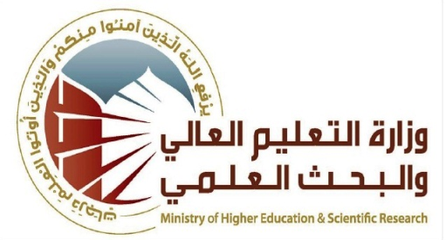

Flow up of implementation celli pass play
Course Instructor | Dr. salam nzhan
E-mail | Salam_nzhan@yahoo.com
Title | Electrical measurements
Course Coordinator
Course Objective | Explain the principal measurement way and instruments with design and its application in the electric engineering
Course Description
Textbook | Electrical Measurements and Instrumentation
Course Assessments | Term Tests | Homeworks | Quizzes | Project | Final Exam
Course Assessments | As(20%) | As(10%) | As(10%) | - | As(60%)
General Notes

University: Diyala
College: Engineering
Department: Electrecal power & Machines
Stage: Third
Lecturer name: Ali Sachit Kaittan
Qualification:
Place of work;

Republic of Iraq
The Ministry Of Higher Education
& Scientific Research

Course Weekly Outline
Week | Date | Topes Covered | Lab. Experiment Assignments | Notes
1 | 6/ 10 / 2016 | System of Units, Fundamental and Derived Units, dimensions
2 | 2 / 11 / 2016 | Standard of Measurements, IEEE Standards
3 | 9 / 11 / 2016 | Review on measuring Instrument, Factors Effecting Instrument selection
4 | 23 / 11 / 2016 | Types of Errors,
5 | 30/ 11/ 2016 | Estimation of Errors and Statistical Analysis of Data
6 | 7/ 12 / 2016 | Gaussian Distribution Curve
7 | 26 / 12/ 2016 | Moving Coil Instruments, Extension of Ammeter and Voltmeter Range
8 | 27/ 12 / 2016 | D.c Ammeter, D.c Voltmeter,
9 | 2 / 1 / 2016 | Extension of Ammeter and Voltmeter Range
10 | 3 / 1 / 2016 | Ohmmeter and Resistance measurement
11 | 9 / 1 / 2016 | Ohmmeter and Resistance measurement

INSTRUCTOR Signature: Dean Signature:
Lec. Dr. Dr. salam nzhan Prof. Dr. AbdulMonem Abbas Karim

